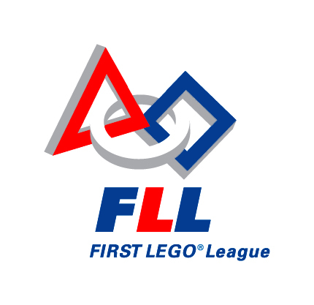
FLL Coaches’ Promise
As the coach of a FIRST LEGO® League (FLL) team, please read the information below for further understanding of FLL core values. As coach, you are responsible for honoring and communicating FLL core values to team members, team volunteers, and others affiliated with your team.
All teams are expected to abide by FLL rules and guidelines as they exist now and as they may be set forth during the season. Team rules, guidelines, and policies and procedures are detailed in this handbook. Any updates, additions, participant consent forms, and volunteer recruitment, screening, and supervision guidelines for the team will be communicated to FLL coaches via email and posted on the FIRST LEGO® League section of www.usfirst.org.
My Promise as Coach:
1) The kids come first. FLL is about the kids having fun and getting excited about science and technology. Everything my team does starts and ends with that principle.
2) The kids do the work. This is their opportunity to learn and grow. The kids on my team do all of the programming, research, problem solving, and building. Adults can help them find the answers, but cannot give them the answers or make the decisions.
3) My team is comprised of ten or fewer members (all team members participate on only one team), registered as an official FLL team, and all team members are no older than 14 on January 1st of the Challenge year.
4) FLL communicates with my team via my primary email address, and I am responsible for reading and relaying all aspects of FLL guidelines and rules to my team, other coaches, volunteers, and parents.
5) I will encourage my team members, other coaches, volunteers, and team supporters to develop and practice a set of FLL Values that reflects FIRST’s goal to change culture in a positive way by inspiring others through our team’s actions and words.
FLL Core Values
- We are a team.
- We do the work to find the solutions with guidance from our coaches and mentors.
- We honor the spirit of friendly competition.
- What we discover is more important than what we win.
- We share our experiences with others.
- We display gracious professionalism in everything we do.
- We have fun!

______________________________________________

Coach

______________________________________________

Assistant Coach

